Moog Analog Eurocard ElectronicsM122- 811 Servoamp

Delta Digital servo controller

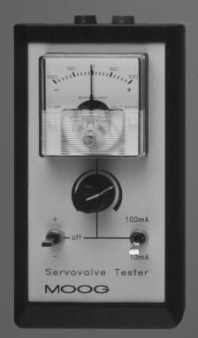Moog servovalve tester/driver

